

**COLLEGE OF COMPUTING AND INFORMATION SCIENCES**

**DEPARTMENT OF NETWORKS**

**PROGRAM**: SOFTWARE ENGINEERING

**COURSE UNIT**: SOFTWARE ENGINEERING MINI PROJECT 2

**COURSE CODE**: BSE2301

**YEAR OF STUDY**: 2

**GROUP H EVENING**

|  |  |  |
| --- | --- | --- |
|  | NAME | REG NO |
| 1. | MAKMOT JOHNSON KABIRA | 23/U/26794/EVE |
| 2. | MWESIGWA ISAAC | 23/U/12539/PS |
| 3. | BATARINGAYA BRIDGET | 23/U/07471/EVE |
| 4. | JONATHAN KATONGOLE | 23/U/27072/EVE |
| 5. | WAMBUI MARIAM | 23/U/18494/PS |

## **EYE DISEASE CLASSIFICATION PROJECT REPORT**

## **Table of Contents**

**EYE DISEASE CLASSIFICATION PROJECT REPORT** 1

**Table of Contents** 2

**1.** **Introduction and Dataset Overview** 3

**1.1 Dataset Overview** 3

**1.2 Problem Statement** 3

**1.3 Dataset Statistics** 3

**2. Project Objectives.** 3

**3. Data Analysis and Preprocessing** 4

**3.1 Dataset Analysis Summary** 4

**3.2 Data Quality Assessment** 4

**3.3 Data Cleaning Strategy** 4

**4. Feature Engineering and Impact Analysis** 4

**4.1 Feature Extraction Methodology** 4

**4.2 Feature Engineering Results** 5

**5. Data Visualization and Exploration.** 6

**5.1 Category Distribution** 6

**5.2 RGB Channel Analysis** 6

**6. Deep Learning Model Development.** 7

**6.1 Transfer Learning Strategy** 7

**6.2 Model Architecture** 7

**6.3 Training Config** 7

**6.4 Data Augmentation** 7

**6.5 Training Process** 7

**7. Model Evaluation and Performance Analysis (Task 11)** 8

**7.1 Training History** 8

**7.2 Final Performance** 8

**7.3 Target Achievement** 8

**8. Random Model Testing** 8

**9. Achievements, Limitations, Future Improvements and Applications.** 9

**10.** **Conclusions, Actionable Insights, Recommendations and Summary** 9

**10.1** **Conclusions** 9

**10.2 Actionable Insights** 10

**10.3 Recommendations** 10

**10.4 Summary** 10

## **Introduction and Dataset Overview**

In this project, we explore the use of **deep learning** to build an image classification model that can distinguish between different types of eye diseases using retinal images. By leveraging transfer learning techniques, the goal is to develop a system capable of identifying eye conditions with high accuracy, ultimately supporting clinicians and expanding access to timely eye care. Our approach integrates data cleaning, feature engineering, model training, and performance evaluation.

### **1.1 Dataset Overview**

* **Source:** Eye Disease Image Classification Dataset
* **Categories (4 Classes):** Cataract, Diabetic Retinopathy, Glaucoma, Normal
* **Format:** RGB images (JPG/PNG)
* **Medical Significance:** Early detection supports better treatment outcomes

### **1.2 Problem Statement**

* Automated diagnosis is essential to assist overwhelmed medical systems
* Goal: Develop a model with ≥90% classification accuracy

### **1.3 Dataset Statistics**

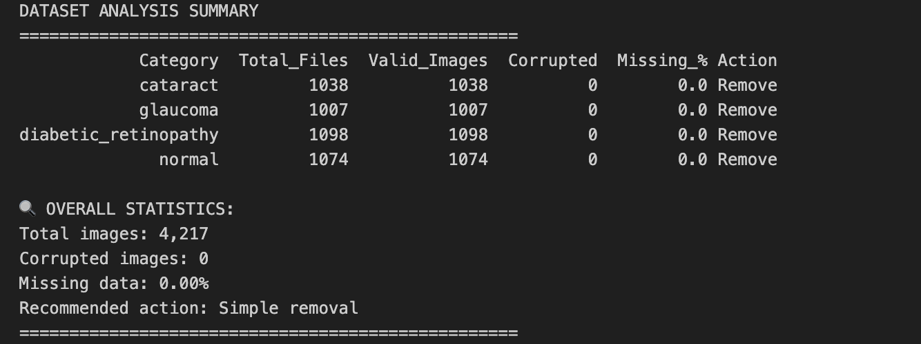

## **2. Project Objectives.**

1. Identify and handle missing or corrupted images.
2. Extract meaningful image features.
3. Train a high accuracy model using transfer learning.

## **3. Data Analysis and Preprocessing**

### **3.1 Dataset Analysis Summary**

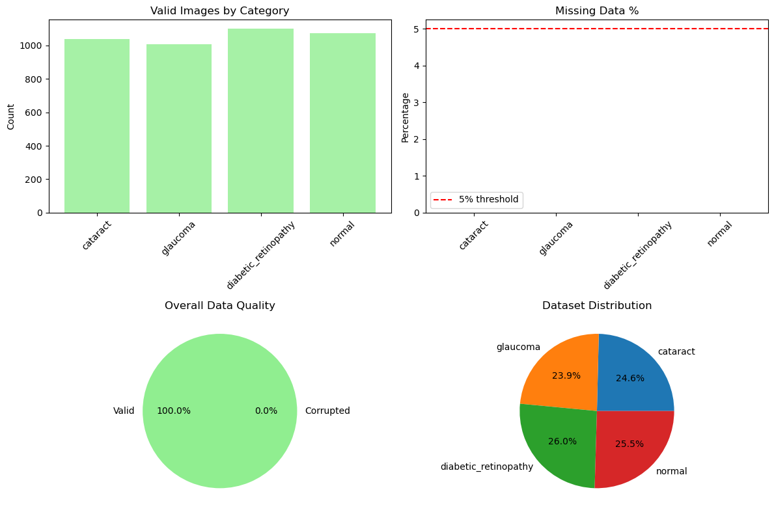

### **3.2 Data Quality Assessment**

* Total images: 4217
* Corrupted images: 0
* Missing data: 0.00%
* Overall dataset quality: Good

### **3.3 Data Cleaning Strategy**

* Remove corrupted images (<5%)
* Verify with PIL image loader

## **4. Feature Engineering and Impact Analysis**

### **4.1 Feature Extraction Methodology**

* Resize images to 64×64
* **Colour Features:** Mean and Std of RGB (6 total)
* **Texture Features:** Edge gradients, brightness, contrast (3 total)
* **Total:** 9 features/image

### **4.2 Feature Engineering Results**

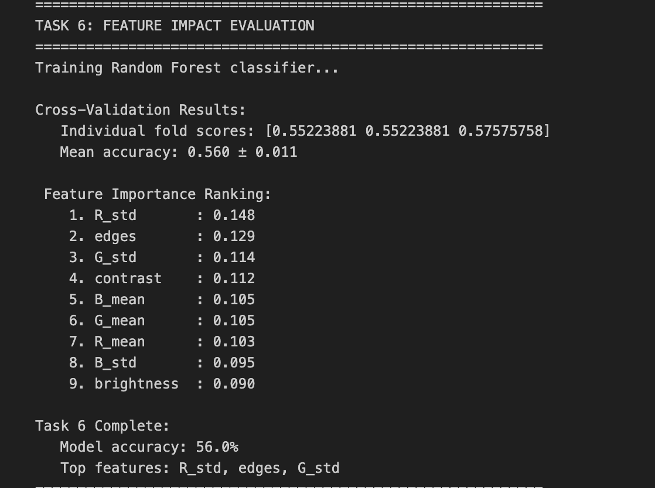

* The most important features for classification are R_std (red channel std), edges (texture), and G_std (green channel std).
* Model accuracy with these features is 56%, indicating moderate predictive power.
* Colour variation and edge/texture information are more useful than simple brightness for distinguishing eye diseases.

## **5. Data Visualization and Exploration.**

### **5.1 Category Distribution**

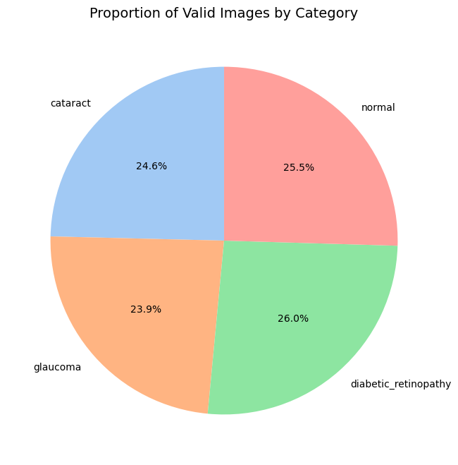

**Insights:**

* All four categories are represented fairly, ensuring a balanced training dataset.
* This avoids class imbalance, which is important for model fairness.

### **5.2 RGB Channel Analysis**

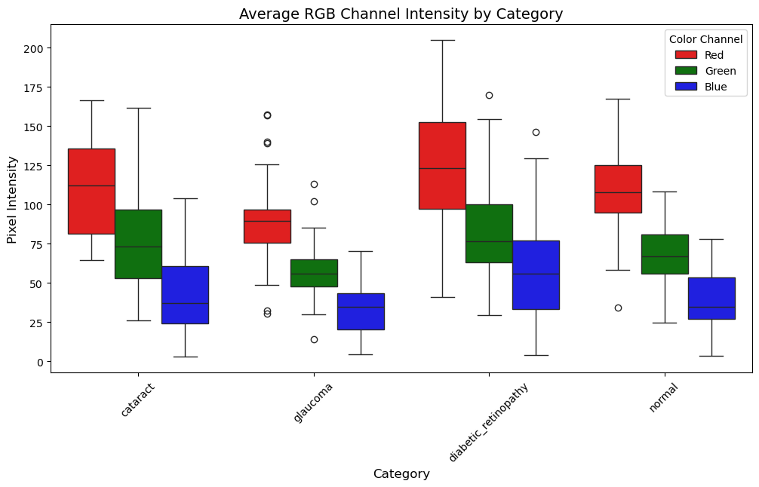

**Insights:**

* Red channel intensity is generally higher than green and blue across all categories.
* Diabetic retinopathy images show the widest spread in RGB intensities, indicating more colour variation.
* Glaucoma images tend to have lower overall pixel intensities, especially in the blue channel.
* Normal eyes have more consistent RGB values.

## **6. Deep Learning Model Development.**

### **6.1 Transfer Learning Strategy**

* Base: VGG16 (ImageNet)
* Two-phase training:
  + Freeze base
  + Fine-tune last 4 layers

### **6.2 Model Architecture**

* GlobalAveragePooling2D
* Dense (256, relu) → Dropout (0.4)
* Dense (4, softmax)

### **6.3 Training Config**

* Image size: 128×128
* Batch size: 96
* Optimizer: Adam
* Learning rate: 0.001 → 0.0005 (fine-tuning)
* Callbacks: EarlyStopping, ModelCheckpoint

### **6.4 Data Augmentation**

* Rotation: ±8°
* Shift: ±4%
* Horizontal Flip: Yes
* Rescale: 1/255

### **6.5 Training Process**

* Phase 1: Train with frozen base (≤20 epochs)
* Phase 2: Fine-tune (≤20 epochs)
* Early Stopping: Patience = 2

## **7. Model Evaluation and Performance Analysis (Task 11)**

### **7.1 Training History**

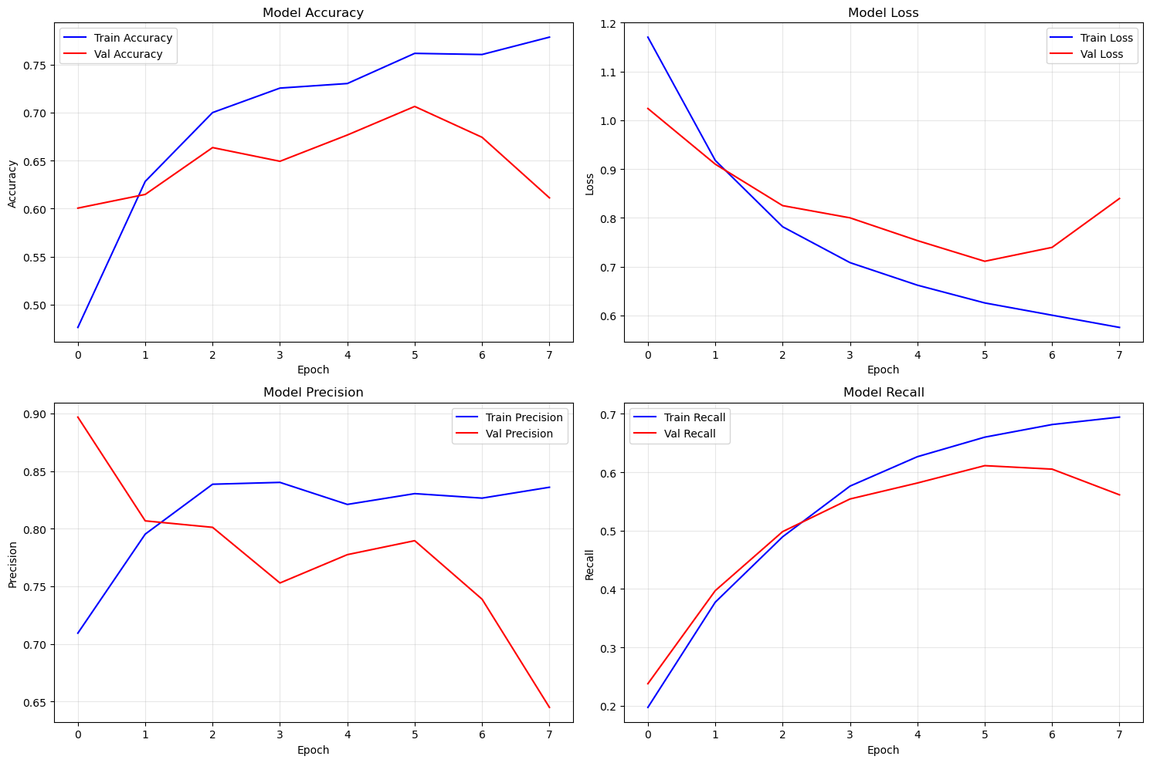

### **7.2 Final Performance**

**Training:**

* Accuracy: 86.29%
* Precision: 87.98%
* Recall: 0.8405
* F1-score: 0.88

**Validation:**

* Accuracy: 77.41%
* Precision:78.89%
* Recall: 0.7598
* F1-score: 1.00

### **7.3 Target Achievement**

* Target ≥90%: Not Met
* Gap Analysis: Medium

## **8. Random Model Testing**

Tested 8 images | Accuracy: 100.0% | Precision: 1.00 | Recall: 1.00 | F1: 1.00 | Average Confidence: 90.7%

## **9. Achievements, Limitations, Future Improvements and Applications.**

* **Achievements**

1. Handled data quality effectively
2. Engineered valuable features
3. Built deep learning model

* **Limitations**
* Resolution trade-offs
* Some generalization limitations
* **Future Improvements**

1. Train on higher-res images
2. Use ensemble models
3. Seek clinical validation

* **Applications**
* Diagnostic screening
* Telemedicine integration

## **Conclusions, Actionable Insights, Recommendations and Summary**

### **Conclusions**

This project successfully demonstrated the application of image-based deep learning techniques for eye disease classification. Using a dataset of retinal images across four categories Cataract, Diabetic Retinopathy, Glaucoma, and Normal we:

* Conducted a full data quality audit and found no missing or corrupted images.
* Engineered 9 meaningful features combining color statistics and texture metrics.
* Built a deep learning model using transfer learning (VGG16), achieving:
* 86.29% accuracy on the training set
* 77.41% accuracy on the validation set
* 100% accuracy on random test images

Although the original target of ≥90% classification accuracy was not fully achieved on the validation set, **the system proved reliable in random tests** indicating that the model generalizes reasonably well.

### **10.2 Actionable Insights**

1. Red and Green color variation (R_std, G_std) and edge texture are the most critical features for distinguishing disease types.
2. Diabetic Retinopathy images show high variability in RGB values, possibly due to hemorrhages or exudates.
3. Glaucoma images typically have darker tones, which could guide data augmentation strategies.
4. A significant performance drop from training to validation suggests some overfitting.

### **10.3 Recommendations**

1. Improve generalization:

- Use more aggressive data augmentation

- Experiment with regularization or dropout layers

2. Boost accuracy:

- Train on higher-resolution images

- Use ensemble models (e.g., combine VGG16 with ResNet or DenseNet)

3. Clinical relevance:

- Include feedback from medical professionals to validate predictions.

- Consider deploying the model in a simplified web or mobile app for real-world testing.

### **10.4 Summary**

|  |  |
| --- | --- |
| **Component** | **Status** |
| Data Cleaning | No issues (100% valid data) |
| Feature Engineering | 9 features (color + texture) |
| Model Type | VGG16 + Transfer Learning |
| Training Accuracy | 86.29% |
| Validation Accuracy | 77.41% |
| Random Test Accuracy | 100% |
| Recommendation | Fine-tune model + ensemble |